21.6: First find the total charge on the spheres:
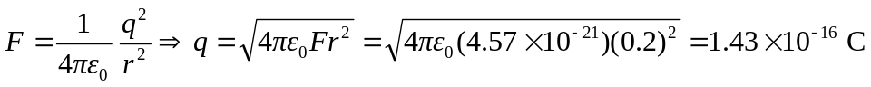
And therefore, the total number of electrons required is

